Project: Library Management

Deadline: the 28th of Nov. Group work

## Library requirement

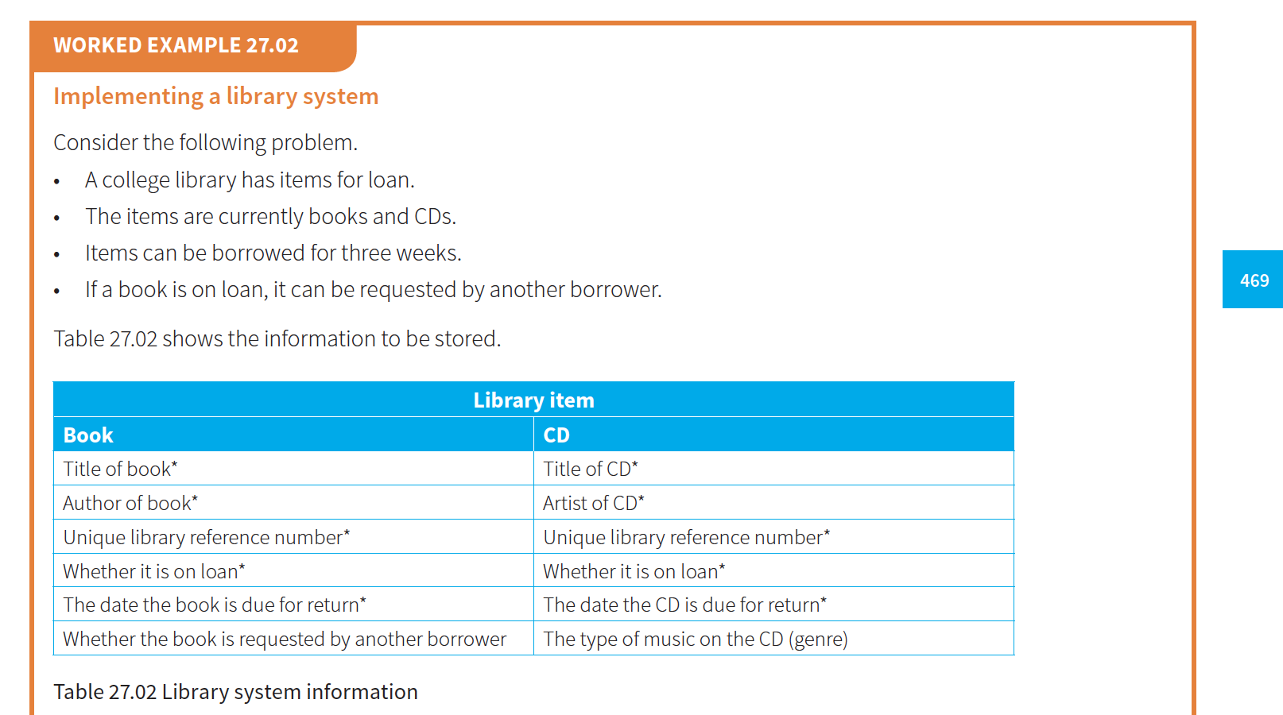

# The UML diagram

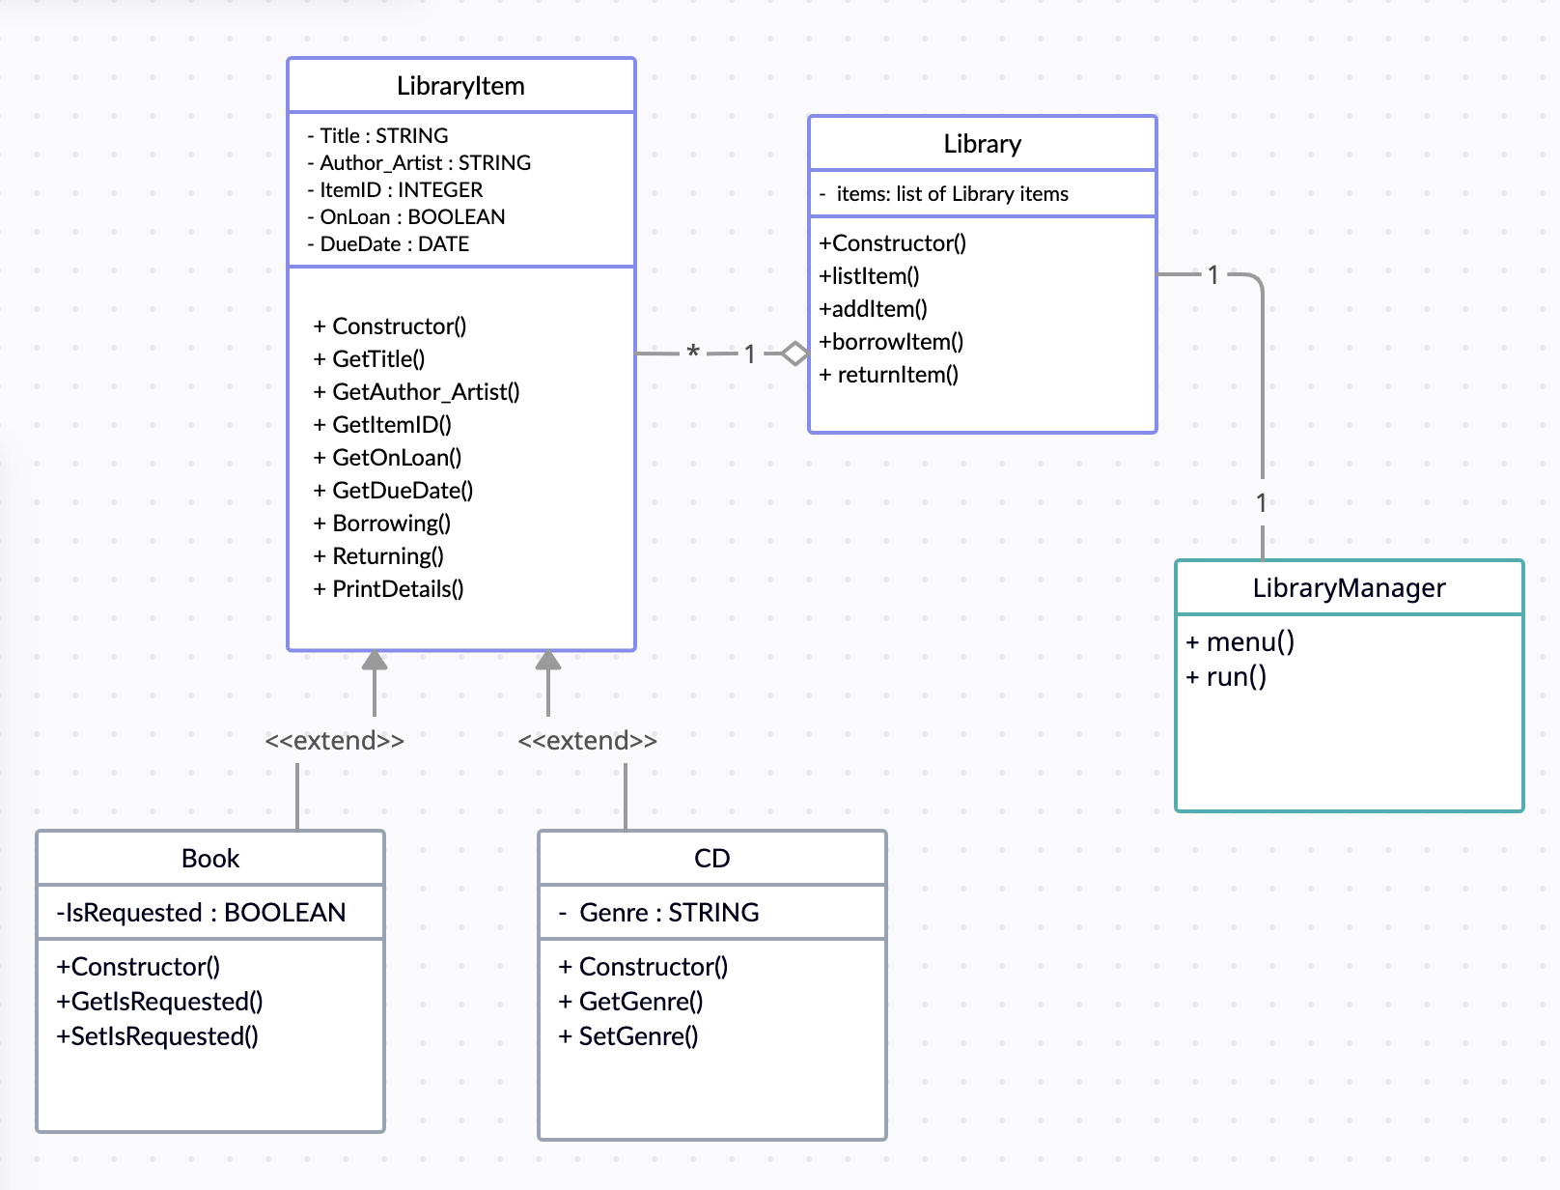

a Borrower class as shown in the class diagram.

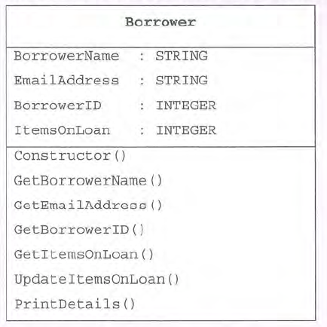

Figure 27.05 Borrower class diagram

The constructor should initialise **ItemsOnLoan** too .

**UpdateitemsOnLoan(**) should increment **ItemsOnLoan** by an integer passed as parameter.

Please add Borrower into your UML diagram and re-design this system.

1. Show you own OOP design UML
2. Realize a consol version of LMS system using OOP technique which should have a menu similar with below:

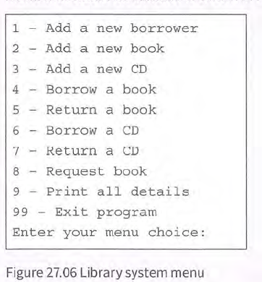

I don’t think this is the perfect design. That is fine if you like to modify this design or its menu to improve it.

You can use a file named as libraryItems.txt to store the Library’s info so that when you begin your app, it can load the info into the system. And store the system into to the file before you exit the system.

Please using AI tools to create your simulate test data for borrowers and library Items.

## The code realization